- What is GIT and GitHub? Explain its features also.
- What are Version Control System? Differentiate between centralized and distributed version control system.
Ans:-
A version control system is a software that tracks changes to a file or set of files over time so that you can recall specific versions later. It also allows you to work together with other programmers.
The version control system is a collection of software tools that help a team to manage changes in a source code. It uses a special kind of database to keep track of every modification to the code.
Developers can compare earlier versions of the code with an older version to fix the mistakes.
Benefits of the Version Control System
The Version Control System is very helpful and beneficial in software development; developing software without using version control is unsafe. It provides backups for uncertainty. Version control systems offer a speedy interface to developers. It also allows software teams to preserve efficiency and agility according to the team scales to include more developers.
Some key benefits of having a version control system are as follows.
o Complete change history of the file
o Simultaneously working
o Branching and merging
o Traceability
Types of Version Control System
o Localized version Control System
o Centralized version control systems
o Distributed version control systems
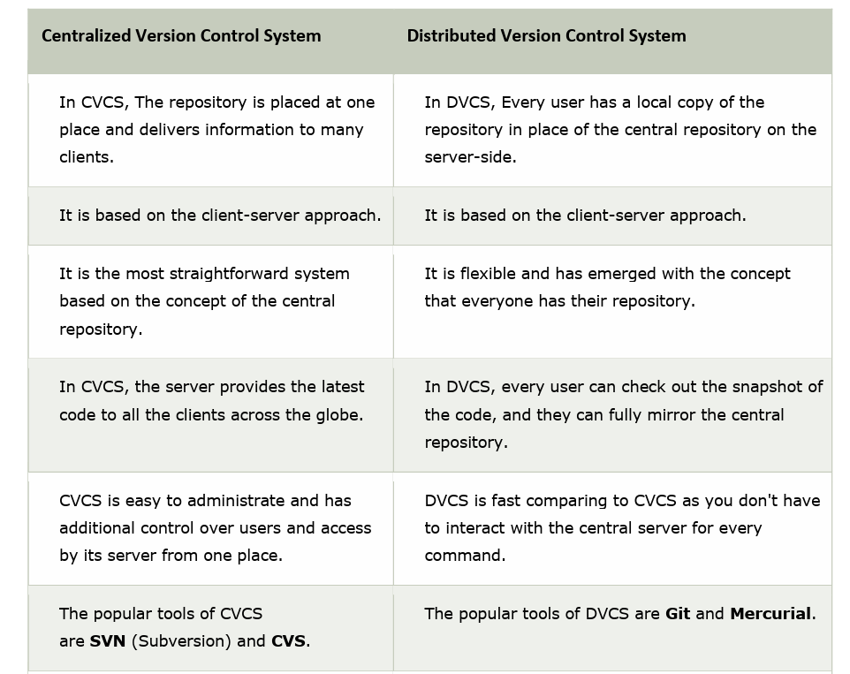
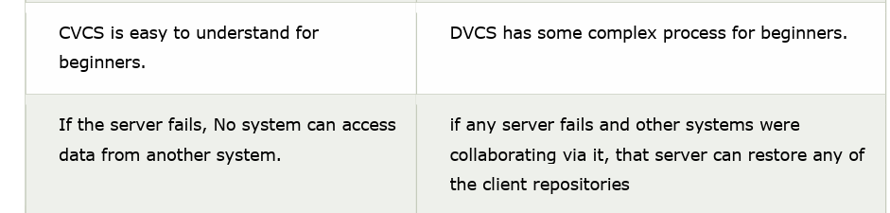

- Explain Agile Methodology.
Ans:- An agile methodology is an iterative approach to software development. Each iteration of agile methodology takes a short time interval of 1 to 4 weeks. The agile development process is aligned to deliver the changing business requirement. It distributes the software with faster and fewer changes.
The single-phase software development takes 6 to 18 months. In single-phase development, all the requirement gathering and risks management factors are predicted initially.
The agile software development process frequently takes the feedback of workable product. The workable product is delivered within 1 to 4 weeks of iteration.
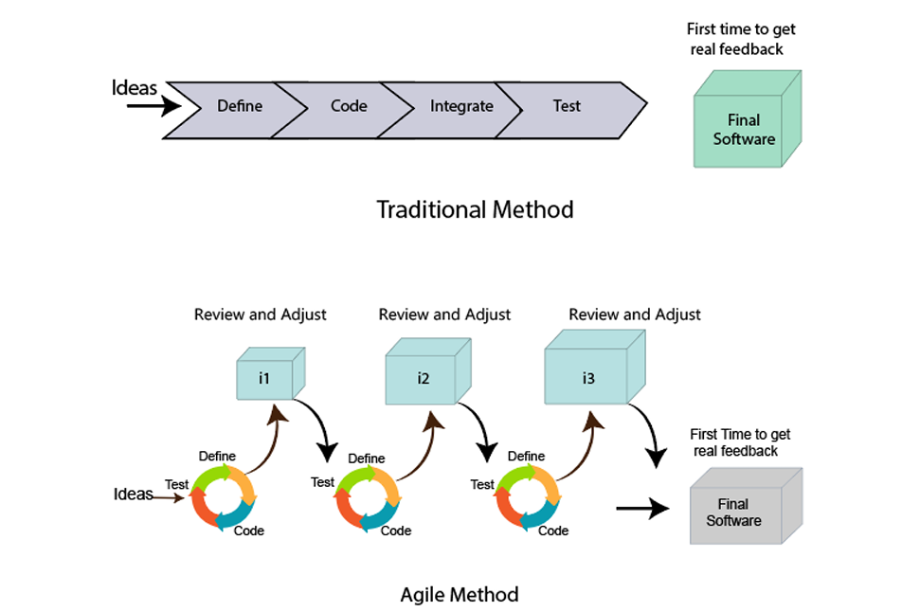
- Explain Manifesto and twelve principles of agile.
Ans:- In February 2001, at the Snowbird resort in Utah, a team of 17 software developers met to discuss lightweight development methods. The result of their meeting was the following Agile Manifesto for software development:-
We are uncovering the better ways of developing software by doing it and helping others to do it. Through this meeting, we have come to value -
o Individuals and interactions over Processes and tools.
o Working software over comprehensive documentation.
o Customers are collaboration over contact negotiation.
o Responding to change over following a plan.
So that, while there is value in the items on the right, we value the items on the left more.
The Twelve Principle of Agile Manifesto
1. Customer Satisfaction: Manifesto provides high priority to satisfy the costumer's requirements. This is done through early and continuous delivery of valuable software.
2. Welcome Change: Making changes during software development is common and inevitable. Every changing requirement should be welcome, evenin the late development phase. Agile process works to increase the customers' competitive advantage.
3. Deliver the Working Software: Deliver the working software frequently, ranging from a few weeks to a few months with considering the shortest time period.
4. Collaboration: Business people (Scrum Master and Project Owner) and developers must work together during the entire life of a project development phase.
5. Motivation: Projects should be build around motivated team members.
Provide such environment that supports individual team members and trust
them. It makes them feel responsible for getting the job done thoroughly.
6. Face-to-face Conversation: Face-to-face conversation between Scrum
Master and development team and between the Scrum Master and customers for the most efficient and effective method of conveying information to and within a development team.
7. Measure the Progress as per the Working Software: The working
software is the key and primary measure of the progress.
8. Maintain Constant Pace: The aim of agile development is sustainable
development. All the businesses and users should be able to maintain a
constant pace with the project.
9. Monitoring: Pay regular attention to technical excellence and good design to maximize agility.
10. Simplicity: Keep things simple and use simple terms to measure the work that is not completed.
11. Self-organized Teams: The Agile team should be self-organized. They
should not be depending heavily on other teams because the best
architectures, requirements, and designs emerge from self-organized teams.
12. Review the Work Regularly: The work should be reviewed at regular
intervals, so that the team can reflect on how to become more productive and adjust its behavior accordingly.
- Explain SRCUM Framework.
Scrum is a framework that helps agile teams to work together. Using it, the team members can deliver and sustain the complex product. It encourages the team to learn through practice, self-organize while working on problem. Scum is a work done through the framework and continuously shipping values to customers.
It is the most frequent software that is used by the development team. Its principle and lessons can be applied to all kinds of teamwork. Its policy and experiences is a reason of popularity of Scrum framework. The Scrum describes a set of tools, meetings, and roles that help the teams structure. It also manages the work done by the team
- The framework
Scrum and agile are not the same thing because Scrum focused on continuous improvement, which is a core foundation of agile. Scrum framework focuses on ongoing getting work done.
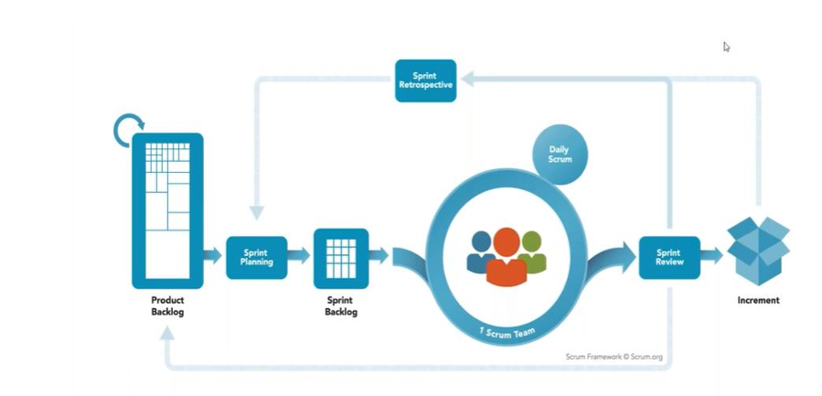
- Explain lean production method.
- Explain CRYSTAL Agile Methodology.
- Explain Agile SDLC.
Ans:-
- Agile Software Development Life Cycle (SDLC)
Software development life cycle (SDLC) is a phenomenon to design, develop and, test high-quality software. The primary aim of SDLC is to produce high-quality software that fulfills the customer requirement within times and cost estimates.
Agile Software Development Life Cycle (SDLC) is the combination of both iterative and incremental process models. It focuses on process adaptability and customer satisfaction by rapid delivery of working software product. Agile SDLC breaks down the product into small incremental builds. These builds are provided into iterations.
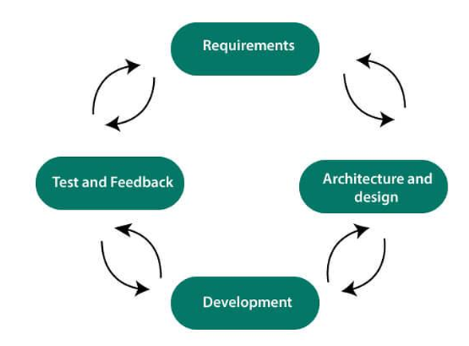
In the agile SDLC development process, the customer is able to see the result and understand whether he/she is satisfied with it or not. This is one of the advantages of the agile SDLC model. One of its disadvantages is the absence of defined requirements so, it is difficult to estimate the resources and development cost.
Each iteration of agile SDLC consists of cross-functional teams working on
various phases:
1. Requirement gathering and analysis
2. Design the requirements
3. Construction/ iteration
4. Deployment
5. Testing
6. Feedback
- Requirements gathering and analysis
In this phase, you must define the requirements. You should explain business opportunities and plan the time and effort needed to build the project. Based on this information, you can evaluate technical and economic feasibility.
- Design the requirements
When you have identified the project, work with stakeholders to define
requirements. You can use the user flow diagram or the high-level UML diagram to show the work of new features and show how it will apply to your existing system.HTML Tutorial
- Construction/ Iteration
When the team defines the requirements, the work begins. The designers and developers start working on their project. The aims of designers and developers deploy the working product within the estimated time. The product will go into various stages of improvement, so it includes simple, minimal functionality.
- Deployment
In this phase, the team issues a product for the user's work environment.
Testing In this phase, the Quality Assurance team examine the product's performance and look for the bug.
- Feedback
After releasing of the product, the last step is to feedback it. In this step, the team receives feedback about the product and works through the feedback.
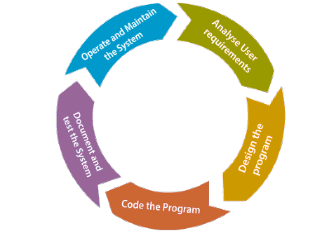
- Give short brief on the following commands and write syntax also:
a.Clone b. status and add c. commit d. Push and Pull
Ans:- Clone:- This command is used to make a copy of a repository from an existing URL. If I want a local copy of my repository from GitHub, this command allows creating a local copy of that repository on your local directory from the repository URL.
Syntax
- $ git clone URL
b. status and add:-
add:-
This command is used to add one or more files to staging (Index) area.
Syntax
To add one file
- $ git add Filename
To add more than one file
- $ git add*
. status
The Git status command gives us all the necessary information about the current branch.
Syntax
git status
6. Git commit
This is maybe the most-used command of Git. Once we reach a certain point in development, we want to save our changes (maybe after a specific task or issue).Git commit is like setting a checkpoint in the development processwhich you can go back to later if needed We also need to write ashort message to explain what we have developed or changed in the source code.
Syntax
git commit -m "commit message"
d. Push and Pull
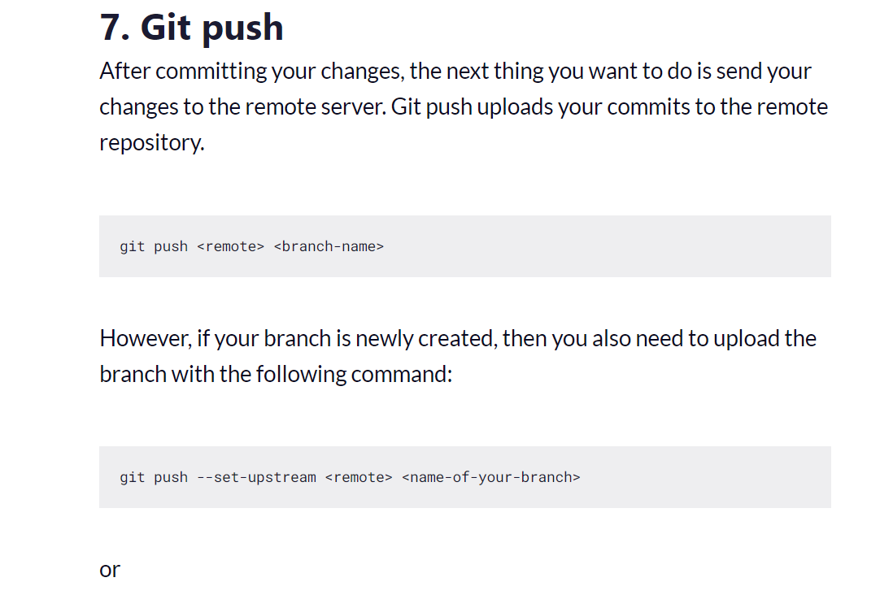
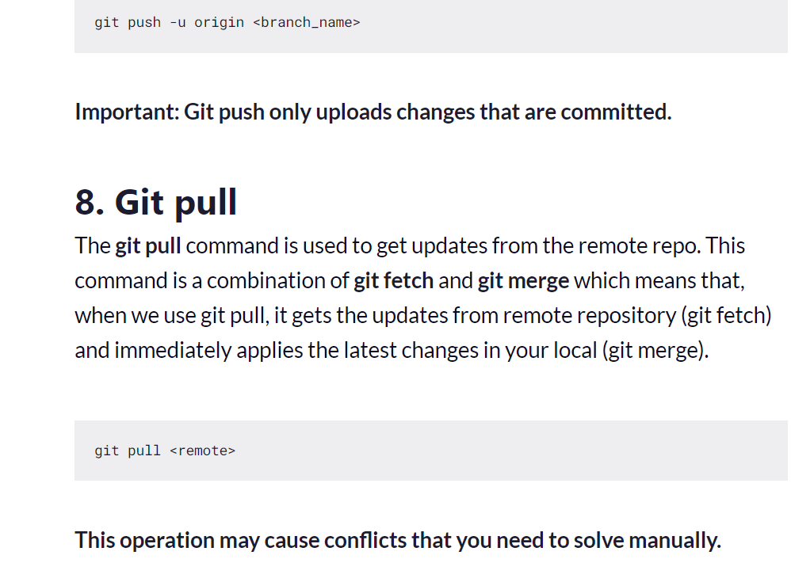

- Explain the properties of CRYSTAL Methodology.
Ans:-
7 properties of Crystal method
• Frequent delivery –
it allows you to frequently deliver working, tested
code to real users. In this way, you don’t have to face the fact that you have invested your energy and time into the product that nobody wants to buy.
• Reflective improvement - no matter how bad or good the product is, there are always areas where the product can be improved. Also, there are always new techniques and methods your team can implement to improve their future practices
• Osmotic communication - with the team who works co-located,
information flows around the team. That allows them to pick up valuable
information without even being directly involved in the discussion of a
certain matter. This gradual absorption of ideas is called osmotic
communication. Cockburn believes that this kind of work atmosphere can operate with very little structure.
• Personal Safety - the only way to build a healthy working atmosphere and a true team culture is by practicing open and honest communication. Team members should be able to speak without fear, no matter whether they are presenting a new idea or talking about a potential problem.
• Focus - each team member knows exactly what to work on which enables them to focus their attention and avoid switching from one task to another. Also, this boosts team communication and helps the team prioritize and work towards the same goals.
• Easy access to expert users - Crystal enables your team to maintain
communication and get regular feedback from real users.
• A technical environment with automated tests, configuration
management, and frequent integration - very specific tools for software
teams where the emphasis is on continuous integration so that the errors
could be caught within minutes.

